
Supervisory Record Form
Meeting 2026/--
Term 1, 2026
Full Name (ID):
Program of Study:
Faculty:

Date of meeting:
Supervisors Present:
Review of actions from the last meeting:
Topics Discussed:
Identification of any issues:
Date and actions set for the next meeting:
Students Signature: |  | Date:
Supervisor’s Signature: |  | Date:
Process for the Electronic Submission of Student-Supervisory Meeting Records
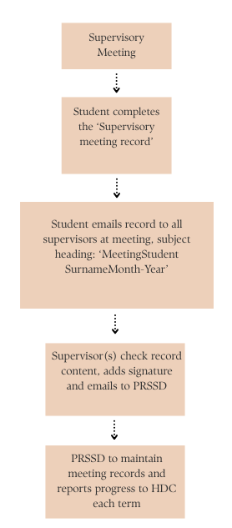

Supervisory meetings can be conducted electronically or by phone, and agreement by email is accepted in lieu of signatures. Students are required to complete a minimum of 8 records per year.

